File Name – default.aspx

<%@ Page Language="C#" AutoEventWireup="true" CodeBehind="Default.aspx.cs" Inherits="WebApplication1.Default" %>

<!DOCTYPE html>

<html xmlns="http://www.w3.org/1999/xhtml">

<head runat="server">

<title></title>

<style>

body {

font-family: Arial, sans-serif;

background-color: lightblue;

margin: 0;

display: flex;

justify-content: center;

align-items: center;

height: 100vh;

}

.container {

background-color:lightcoral;

padding: 20px;

border-radius: 8px;

box-shadow: 0 0 10px rgba(0, 0, 0, 0.1);

width: 400px;

text-align: center;

border-style: solid;

}

h2 {

color: #333;

}

.tlabel {

display: block;

margin: 10px 0;

color: #555;

}

button{

padding: 10px 20px;

background-color: #4caf50;

color: #fff;

border: none;

border-radius: 4px;

cursor: pointer;

margin-top: 10px;

}

</style>

</head>

<body>

<form id="form1" runat="server">

<div class="container">

<h2><center>Registration Form</center></h2>

<p>

<label>Enter Name :</label>

<asp:TextBox ID="t_name" runat="server" class="tlable"></asp:TextBox>

</p>

<p>

<label>Enter Email ID :</label>

<asp:TextBox ID="t_email" runat="server" class="tlable"></asp:TextBox>

</p>

<p>

<label>Enter Password :</label>

<asp:TextBox ID="t_password" runat="server" class="tlable"></asp:TextBox>

</p>

<p>

<label>Enter Mobile :</label>

<asp:TextBox ID="t_mobile" runat="server" class="tlable"></asp:TextBox>

</p>

<p>

<label>Upload Photo :</label>

<asp:FileUpload ID="img" runat="server" accept=".png,.jpg,.jpeg,.gif"/>

</p>

<p>

<label>Date of Registration :</label>

<asp:TextBox ID="T_date" runat="server" class="tlable"></asp:TextBox>

</p>

<p>

<asp:Button ID="Btn_login" runat="server" Text="Login Button" OnClick="Btn_login_Click" />

</p>

</div>

</form>

</body>

</html>

File Name default.aspx.cs

using System;

using System.Collections.Generic;

using System.Linq;

using System.Web;

using System.Web.UI;

using System.Web.UI.WebControls;

namespace WebApplication1

{

public partial class Default : System.Web.UI.Page

{

protected void Page_Load(object sender, EventArgs e)

{

T_date.Text = DateTime.Now.ToString("dd/MM/yyyy");

}

protected void Btn_login_Click(object sender, EventArgs e)

{

try

{

if(t_name.Text == "" && t_email.Text == "" && t_password.Text == "" && t_mobile.Text == "")

{

Response.Write("All File Are require");

}

else

{

Session["name"] = t_name.Text;

Session["email"] = t_email.Text;

Session["pass"] = t_password.Text;

Session["mobile"] = t_mobile.Text;

img.SaveAs(Server.MapPath("~") + "//upload//" + img.FileName);

Session["img"] = img.FileName;

Response.Redirect("Login.aspx");

}

}

catch(Exception d)

{

Response.Write(d.ToString());

}

}

}

}

File Name – login.aspx

<%@ Page Language="C#" AutoEventWireup="true" CodeBehind="Login.aspx.cs" Inherits="WebApplication1.Login" %>

<!DOCTYPE html>

<html xmlns="http://www.w3.org/1999/xhtml">

<head runat="server">

<title></title>

<style>

body {

font-family: Arial, sans-serif;

background-color: lightblue;

margin: 0;

display: flex;

justify-content: center;

align-items: center;

height: 100vh;

}

.container {

background-color:lightcoral;

padding: 20px;

border-radius: 8px;

box-shadow: 0 0 10px rgba(0, 0, 0, 0.1);

width: 400px;

text-align: center;

border-style: solid;

}

</style>

</head>

<body>

<form id="form1" runat="server">

<div>

</div>

<div class="container">

<h2><center>Login</center></h2>

<p>

<label>Enter Email :</label>

<asp:TextBox ID="t_email" runat="server" class="tlable"></asp:TextBox>

</p>

<p>

<label>Enter Password:</label>

<asp:TextBox ID="t_password" runat="server" class="tlable"></asp:TextBox>

</p>

<p>

<asp:Button ID="Button1" runat="server" Text="Login" OnClick="Button1_Click" />

</div>

</form>

</body>

</html>

File Name login.aspx.cs

using System;

using System.Collections.Generic;

using System.Linq;

using System.Web;

using System.Web.UI;

using System.Web.UI.WebControls;

namespace WebApplication1

{

public partial class Login : System.Web.UI.Page

{

protected void Page_Load(object sender, EventArgs e)

{

}

protected void Button1_Click(object sender, EventArgs e)

{

ViewState["email"] = t_email.Text;

ViewState["password"] = t_password.Text;

try

{

if ((string)Session["email"] == ViewState["email"].ToString() && (string)Session["pass"] == ViewState["password"].ToString())

{

Response.Redirect("Exam.aspx");

}

else

{

Response.Write("Invalid User");

}

}

catch(Exception p1)

{

}

}

}

}

File Name – exam.aspx

<%@ Page Language="C#" AutoEventWireup="true" CodeBehind="Exam.aspx.cs" Inherits="WebApplication1.Exam" %>

<!DOCTYPE html>

<html xmlns="http://www.w3.org/1999/xhtml">

<head runat="server">

<title></title>

<style>

body {

font-family: Arial, sans-serif;

background-color: lightblue;

margin: 0;

display: flex;

justify-content: center;

align-items: center;

height: 100vh;

}

.container {

background-color:lightcoral;

padding: 20px;

border-radius: 8px;

box-shadow: 0 0 10px rgba(0, 0, 0, 0.1);

width: 400px;

text-align: center;

border-style: solid;

}

</style>

</head>

<body>

<form id="form1" runat="server">

<div>

<div class="container">

<h2><center>Login</center></h2>

<p>

Student N<label>ame :</label>

<asp:Label ID="t_name" runat="server" Text="Label"></asp:Label>

</p>

<p>

<label>Student Email :</label>

<asp:Label ID="t_email" runat="server" Text="Label"></asp:Label>

</p>

<p>

<label>College Name :</label>

<asp:TextBox ID="t_college" runat="server" class="tlable"></asp:TextBox>

</p>

<p>

<label>Branch Name :</label>

<asp:TextBox ID="t_branch" runat="server" class="tlable"></asp:TextBox>

</p>

<label>Semester :</label>

<asp:DropDownList ID="DropDownList1" runat="server">

<asp:ListItem>Select</asp:ListItem>

<asp:ListItem>1</asp:ListItem>

<asp:ListItem>2</asp:ListItem>

<asp:ListItem>3</asp:ListItem>

<asp:ListItem>4</asp:ListItem>

<asp:ListItem>5</asp:ListItem>

<asp:ListItem>6</asp:ListItem>

<asp:ListItem>7</asp:ListItem>

<asp:ListItem>8</asp:ListItem>

</asp:DropDownList>

<p>

<asp:Button ID="Button1" runat="server" Text="Start Test" OnClick="Button1_Click" />

</div>

</div>

</form>

</body>

</html>

File Name – exam.aspx.cs

using System;

using System.Collections.Generic;

using System.Linq;

using System.Web;

using System.Web.UI;

using System.Web.UI.WebControls;

namespace WebApplication1

{

public partial class testscreen : System.Web.UI.Page

{

protected void Page_Load(object sender, EventArgs e)

{

col_name.Text = (string)Session["col_name"];

l_name.Text = (string)Session["name"];

l_email.Text = (string)Session["email"];

l_sem.Text = (string)Session["sem"];

Image1.ImageUrl = "~/upload/" + (string)Session["img"];

Session["mark"] = 0;

}

protected void Button1_Click(object sender, EventArgs e)

{

MultiView1.ActiveViewIndex = 0;

}

protected void Button2_Click(object sender, EventArgs e)

{

MultiView1.ActiveViewIndex = 1;

}

protected void que3_Click(object sender, EventArgs e)

{

MultiView1.ActiveViewIndex = 2;

}

protected void que4_Click(object sender, EventArgs e)

{

MultiView1.ActiveViewIndex = 3;

}

protected void que5_Click(object sender, EventArgs e)

{

MultiView1.ActiveViewIndex = 4;

}

protected void que6_Click(object sender, EventArgs e)

{

MultiView1.ActiveViewIndex = 5;

}

protected void que7_Click(object sender, EventArgs e)

{

MultiView1.ActiveViewIndex = 6;

}

protected void que8_Click(object sender, EventArgs e)

{

MultiView1.ActiveViewIndex = 7;

}

protected void que9_Click(object sender, EventArgs e)

{

MultiView1.ActiveViewIndex = 8;

}

protected void que10_Click(object sender, EventArgs e)

{

MultiView1.ActiveViewIndex = 9;

}

protected void Score_Click(object sender, EventArgs e)

{

int sum = 0;

if (RadioButtonList1.SelectedIndex == 1)

{

sum++;

}

if (RadioButtonList2.SelectedIndex == 0)

{

sum++;

}

if (RadioButtonList3.SelectedIndex == 0)

{

sum++;

}

if (RadioButtonList4.SelectedIndex == 1)

{

sum++;

}

if (RadioButtonList5.SelectedIndex == 0)

{

sum++;

}

if (RadioButtonList6.SelectedIndex == 2)

{

sum++;

}

if (RadioButtonList7.SelectedIndex == 2)

{

sum++;

}

if (RadioButtonList8.SelectedIndex == 1)

{

sum++;

}

if (RadioButtonList9.SelectedIndex == 3)

{

sum++;

}

if (RadioButtonList10.SelectedIndex == 0)

{

sum++;

}

Session["mark"] = sum;

Response.Redirect("score.aspx");

}

}

}

File Name – testscreen.aspx

<%@ Page Language="C#" AutoEventWireup="true" CodeBehind="testscreen.aspx.cs" Inherits="WebApplication1.testscreen" %>

<!DOCTYPE html>

<html xmlns="http://www.w3.org/1999/xhtml">

<head runat="server">

<title></title>

<style>

body{

background-color:lightgreen;

}

.col {

position: absolute;

left: 200px;

}

.info {

position: absolute;

margin-left: 60%;

}

.imgclas {

position: absolute;

margin-left: 80%;

width: 80%;

}

.upperd{

width:100%;

height:200px;

}

.allque{

position:absolute;

left: 200px;

}

.allbtn{

position : absolute;

margin-left : 60%;

top : 150px

}

#que1{

margin:10px;

}

#que2{

margin:10px;

}

#que3{

margin:10px;

}

#que4{

margin:10px;

}

#que5{

margin:10px;

}

#que6{

margin:10px;

}

#que7{

margin:10px;

}

#que8{

margin:10px;

}

#que9{

margin:10px;

}

#que10{

margin:10px;

}

#Score{

position:absolute;

top: 500px;

left : 500px

}

</style>

</head>

<body>

<form id="form1" runat="server">

<div class="container">

<div class="upperd">

<div class="col">

<h1>Online Exam Module<br />

<asp:Label ID="col_name" runat="server" Text="Label"></asp:Label>

</h1>

</div>

<div class="info">

Name :

<asp:Label ID="l_name" runat="server" Text="Label"></asp:Label><br />

Email :

<asp:Label ID="l_email" runat="server" Text="Label"></asp:Label><br>

Branch :

<asp:Label ID="l_branch" runat="server" Text="Label"></asp:Label><br>

Semester :

<asp:Label ID="l_sem" runat="server" Text="Label"></asp:Label><br>

</div>

<div class="imgclas">

<asp:Image ID="Image1" runat="server" Width="100px" Height="100px" />

</div>

</div>

<div>

<div class="allque">

<asp:MultiView ID="MultiView1" runat="server">

<asp:View ID="View1" runat="server">

Question 1 : What is the implicit return typr of Constructor?<br />

<asp:RadioButtonList ID="RadioButtonList1" runat="server">

<asp:ListItem>No return type</asp:ListItem>

<asp:ListItem>A class object in which it is define</asp:ListItem>

<asp:ListItem>void</asp:ListItem>

<asp:ListItem>None</asp:ListItem>

</asp:RadioButtonList>

</asp:View>

<asp:View ID="View2" runat="server">

Question 2 : Which is the object created with new keyword?

<asp:RadioButtonList ID="RadioButtonList2" runat="server">

<asp:ListItem>At run time</asp:ListItem>

<asp:ListItem>At compile time</asp:ListItem>

<asp:ListItem>Depends on the code</asp:ListItem>

<asp:ListItem>None</asp:ListItem>

</asp:RadioButtonList>

</asp:View>

<asp:View ID="View3" runat="server">

Question 3 : Identify the incorrect constructor type.

<asp:RadioButtonList ID="RadioButtonList3" runat="server">

<asp:ListItem>Friend Constructor</asp:ListItem>

<asp:ListItem>Default Constructor</asp:ListItem>

<asp:ListItem>Parameterized Constructor</asp:ListItem>

<asp:ListItem>Copy Constructor</asp:ListItem>

</asp:RadioButtonList>

</asp:View>

<asp:View ID="View4" runat="server">

Question 4 : Identify the scope resolution operator.

<asp:RadioButtonList ID="RadioButtonList4" runat="server">

<asp:ListItem>:</asp:ListItem>

<asp:ListItem>::</asp:ListItem>

<asp:ListItem>?:</asp:ListItem>

<asp:ListItem>None</asp:ListItem>

</asp:RadioButtonList>

</asp:View>

<asp:View ID="View5" runat="server">

Question 5 : Choose the option below which is not a member of the class.

<asp:RadioButtonList ID="RadioButtonList5" runat="server">

<asp:ListItem>Friend Function</asp:ListItem>

<asp:ListItem>Static Function</asp:ListItem>

<asp:ListItem>Virtual Function</asp:ListItem>

<asp:ListItem>Const Function</asp:ListItem>

</asp:RadioButtonList>

</asp:View>

<asp:View ID="View6" runat="server">

Question 6 : Total types of constructors in C++ are?

<asp:RadioButtonList ID="RadioButtonList6" runat="server">

<asp:ListItem>1</asp:ListItem>

<asp:ListItem>2</asp:ListItem>

<asp:ListItem>3</asp:ListItem>

<asp:ListItem>4</asp:ListItem>

</asp:RadioButtonList>

</asp:View>

<asp:View ID="View7" runat="server">

Question 7 : Which of the following is not a type of inheritance?

<asp:RadioButtonList ID="RadioButtonList7" runat="server">

<asp:ListItem>Multiple</asp:ListItem>

<asp:ListItem>Multilevel</asp:ListItem>

<asp:ListItem>Distributed</asp:ListItem>

<asp:ListItem>Hierarchical</asp:ListItem>

</asp:RadioButtonList>

</asp:View>

<asp:View ID="View8" runat="server">

Question 8 : What is an object in C++?

<asp:RadioButtonList ID="RadioButtonList8" runat="server">

<asp:ListItem>It is a function of class</asp:ListItem>

<asp:ListItem>It is an instance of the class</asp:ListItem>

<asp:ListItem>it is a the data type of class</asp:ListItem>

<asp:ListItem>it is part of the syntax of class</asp:ListItem>

</asp:RadioButtonList>

</asp:View>

<asp:View ID="View9" runat="server">

Question 9 : Identify the operators which cannot be overloaded.

<asp:RadioButtonList ID="RadioButtonList9" runat="server">

<asp:ListItem>?:</asp:ListItem>

<asp:ListItem>.(dot operator)</asp:ListItem>

<asp:ListItem>&gt;&gt;</asp:ListItem>

<asp:ListItem>Both A and B</asp:ListItem>

</asp:RadioButtonList>

</asp:View>

<asp:View ID="View10" runat="server">

Question 10 : By default, fields in a structure of a C program is?

<asp:RadioButtonList ID="RadioButtonList10" runat="server">

<asp:ListItem>Public</asp:ListItem>

<asp:ListItem>Private</asp:ListItem>

<asp:ListItem>Protected</asp:ListItem>

<asp:ListItem>None</asp:ListItem>

</asp:RadioButtonList>

</asp:View>

</asp:MultiView>

</div>

<div class="allbtn">

<asp:Button ID="que1" runat="server" Text="1" OnClick="Button1_Click" Height="30px" Width="30px" />

<asp:Button ID="que2" runat="server" Text="2" OnClick="Button2_Click" Height="30px" width="30px"/>

<asp:Button ID="que3" runat="server" Text="3" OnClick="que3_Click" Height="30px" width="30px"/><br />

<asp:Button ID="que4" runat="server" Text="4" OnClick="que4_Click" Height="30px" width="30px"/>

<asp:Button ID="que5" runat="server" Text="5" OnClick="que5_Click" Height="30px" width="30px"/>

<asp:Button ID="que6" runat="server" Text="6" OnClick="que6_Click" Height="30px" width="30px"/><br />

<asp:Button ID="que7" runat="server" Text="7" OnClick="que7_Click" Height="30px" width="30px"/>

<asp:Button ID="que8" runat="server" Text="8" OnClick="que8_Click" Height="30px" width="30px"/>

<asp:Button ID="que9" runat="server" Text="9" OnClick="que9_Click" Height="30px" width="30px"/><br />

<asp:Button ID="que10" runat="server" Text="10" OnClick="que10_Click" Height="30px" width="30px"/>

</div>

</div>

</div>

<div>

<asp:Button ID="Score" runat="server" Text="Button" OnClick="Score_Click" />

</div>

</form>

</body>

</html>

File Name – testscreen.aspx.cs

using System;

using System.Collections.Generic;

using System.Linq;

using System.Web;

using System.Web.UI;

using System.Web.UI.WebControls;

namespace WebApplication1

{

public partial class testscreen : System.Web.UI.Page

{

protected void Page_Load(object sender, EventArgs e)

{

col_name.Text = (string)Session["col_name"];

l_name.Text = (string)Session["name"];

l_email.Text = (string)Session["email"];

l_sem.Text = (string)Session["sem"];

Image1.ImageUrl = "~/upload/" + (string)Session["img"];

Session["mark"] = 0;

}

protected void Button1_Click(object sender, EventArgs e)

{

MultiView1.ActiveViewIndex = 0;

}

protected void Button2_Click(object sender, EventArgs e)

{

MultiView1.ActiveViewIndex = 1;

}

protected void que3_Click(object sender, EventArgs e)

{

MultiView1.ActiveViewIndex = 2;

}

protected void que4_Click(object sender, EventArgs e)

{

MultiView1.ActiveViewIndex = 3;

}

protected void que5_Click(object sender, EventArgs e)

{

MultiView1.ActiveViewIndex = 4;

}

protected void que6_Click(object sender, EventArgs e)

{

MultiView1.ActiveViewIndex = 5;

}

protected void que7_Click(object sender, EventArgs e)

{

MultiView1.ActiveViewIndex = 6;

}

protected void que8_Click(object sender, EventArgs e)

{

MultiView1.ActiveViewIndex = 7;

}

protected void que9_Click(object sender, EventArgs e)

{

MultiView1.ActiveViewIndex = 8;

}

protected void que10_Click(object sender, EventArgs e)

{

MultiView1.ActiveViewIndex = 9;

}

protected void Score_Click(object sender, EventArgs e)

{

int sum = 0;

if (RadioButtonList1.SelectedIndex == 1)

{

sum++;

}

if (RadioButtonList2.SelectedIndex == 0)

{

sum++;

}

if (RadioButtonList3.SelectedIndex == 0)

{

sum++;

}

if (RadioButtonList4.SelectedIndex == 1)

{

sum++;

}

if (RadioButtonList5.SelectedIndex == 0)

{

sum++;

}

if (RadioButtonList6.SelectedIndex == 2)

{

sum++;

}

if (RadioButtonList7.SelectedIndex == 2)

{

sum++;

}

if (RadioButtonList8.SelectedIndex == 1)

{

sum++;

}

if (RadioButtonList9.SelectedIndex == 3)

{

sum++;

}

if (RadioButtonList10.SelectedIndex == 0)

{

sum++;

}

Session["mark"] = sum;

Response.Redirect("score.aspx");

}

}

}

File Name Score.aspx

<%@ Page Language="C#" AutoEventWireup="true" CodeBehind="score.aspx.cs" Inherits="WebApplication1.score" %>

<!DOCTYPE html>

<html xmlns="http://www.w3.org/1999/xhtml">

<head runat="server">

<title></title>

<style>

body {

background-color:lightpink

font-family: Arial, sans-serif;

display: flex;

justify-content: center;

align-items: center;

height: 100vh;

margin: 0;

background-color: lime;

}

.container {

text-align: center;

background-color: lightcoral;

padding: 20px;

border-radius: 8px;

box-shadow: 0 0 10px rgba(0, 0, 0, 0.1);

width : 600px;

}

label {

padding-bottom:20px;

margin: 10px 0;

}

label {

padding: 8px;

margin: 5px 0;

width: 100%;

box-sizing: border-box;

}

button {

padding: 10px 20px;

background-color: #4caf50;

color: #fff;

border: none;

border-radius: 4px;

cursor: pointer;

margin-top: 10px;

}

.result {

margin-top: 20px;

border-top: 1px solid #ccc;

padding-top: 10px;

}

</style>

</head>

<body>

<form id="form1" runat="server">

<div>

<div class="container">

<asp:Image ID="Image1" runat="server" Height="130px" Width="104px" />

<br />

<h2>Marksheet </h2>

<form id="markForm">

<label for="name">

<br />

Name:</label><asp:Label ID="name" runat="server" Text="Label"></asp:Label><br />

<label for="email">Email:</label><asp:Label ID="email" runat="server" Text="Label"></asp:Label><br>

<label for="branch">Branch:</label><asp:Label ID="branch" runat="server" Text="Label"></asp:Label><br>

<label for="sem">Semester:</label><asp:Label ID="sem" runat="server" Text="Label"></asp:Label><br>

<label for="grade">Grade:</label><asp:Label ID="grade" runat="server" Text="Label"></asp:Label><label for="total">

<br />

Total Marks:</label></label><asp:Label ID="mark" runat="server" Text="Label"></asp:Label>

</form>

<div class="result" id="resultSection"></div>

</div>

</div>

</form>

</body>

</html>

File Name – Score.aspx.html

<%@ Page Language="C#" AutoEventWireup="true" CodeBehind="score.aspx.cs" Inherits="WebApplication1.score" %>

<!DOCTYPE html>

<html xmlns="http://www.w3.org/1999/xhtml">

<head runat="server">

<title></title>

<style>

body {

background-color:lightpink

font-family: Arial, sans-serif;

display: flex;

justify-content: center;

align-items: center;

height: 100vh;

margin: 0;

background-color: lime;

}

.container {

text-align: center;

background-color: lightcoral;

padding: 20px;

border-radius: 8px;

box-shadow: 0 0 10px rgba(0, 0, 0, 0.1);

width : 600px;

}

label {

padding-bottom:20px;

margin: 10px 0;

}

label {

padding: 8px;

margin: 5px 0;

width: 100%;

box-sizing: border-box;

}

button {

padding: 10px 20px;

background-color: #4caf50;

color: #fff;

border: none;

border-radius: 4px;

cursor: pointer;

margin-top: 10px;

}

.result {

margin-top: 20px;

border-top: 1px solid #ccc;

padding-top: 10px;

}

</style>

</head>

<body>

<form id="form1" runat="server">

<div>

<div class="container">

<asp:Image ID="Image1" runat="server" Height="130px" Width="104px" />

<br />

<h2>Marksheet </h2>

<form id="markForm">

<label for="name">

<br />

Name:</label><asp:Label ID="name" runat="server" Text="Label"></asp:Label><br />

<label for="email">Email:</label><asp:Label ID="email" runat="server" Text="Label"></asp:Label><br>

<label for="branch">Branch:</label><asp:Label ID="branch" runat="server" Text="Label"></asp:Label><br>

<label for="sem">Semester:</label><asp:Label ID="sem" runat="server" Text="Label"></asp:Label><br>

<label for="grade">Grade:</label><asp:Label ID="grade" runat="server" Text="Label"></asp:Label><label for="total">

<br />

Total Marks:</label></label><asp:Label ID="mark" runat="server" Text="Label"></asp:Label>

</form>

<div class="result" id="resultSection"></div>

</div>

</div>

</form>

</body>

</html>

Screen 1

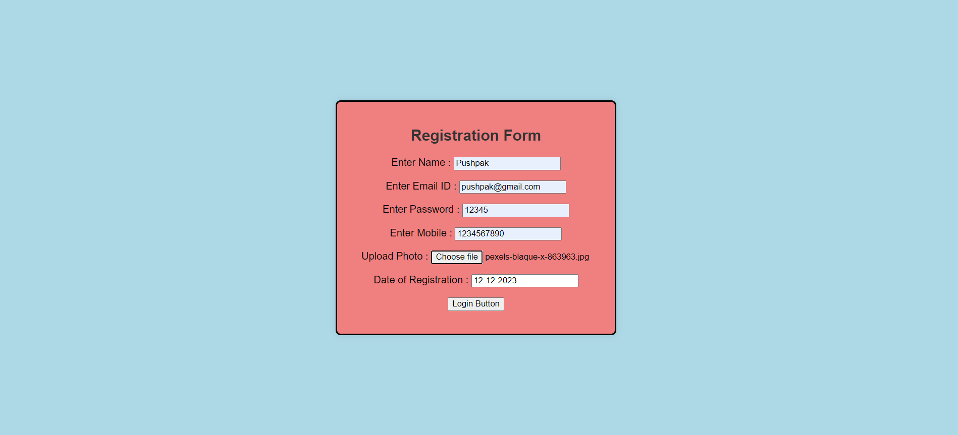

Screen 2

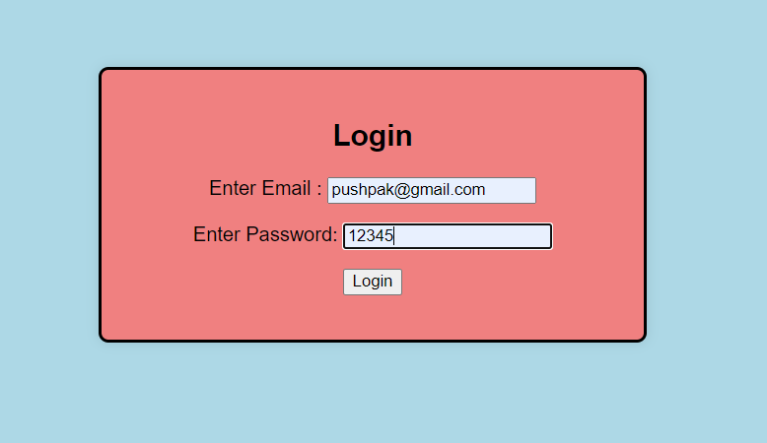

Screen 3 –

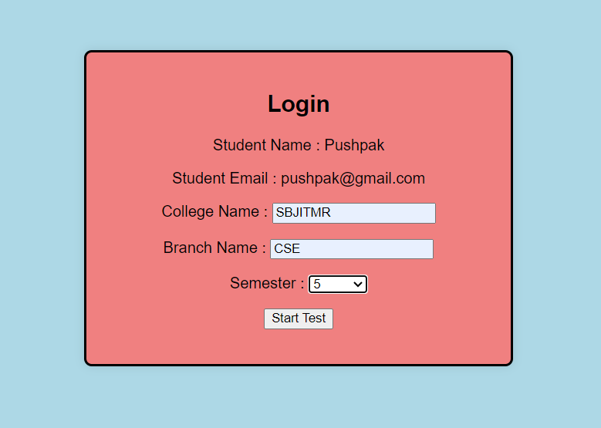

Screen 4 –

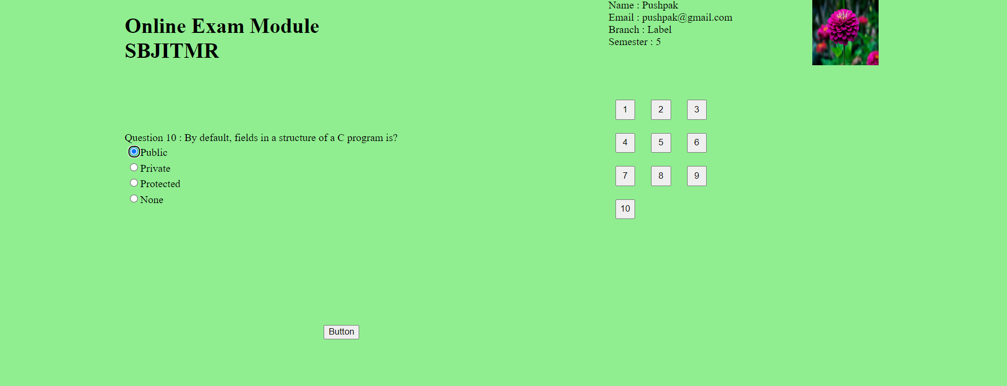

Screen 5 –

